Sliding Window Protocol | Set 3 (Selective Repeat)

Why Selective Repeat Protocol?
The go-back-n protocol works well if errors are less, but if the line is poor it wastes a lot of bandwidth on retransmitted frames.
- An alternative strategy, the selective repeat protocol, is to allow the receiver to accept and buffer the frames following a damaged or lost one.
- Selective Repeat attempts to retransmit only those packets that are actually lost (due to errors) :

- Receiver must be able to accept packets out of order.
- Since receiver must release packets to higher layer in order, the receiver must be able to buffer some packets.
Retransmission requests :
- Implicit –The receiver acknowledges every good packet, packets that are not ACKed before a time-out are assumed lost or in error.Notice that this approach must be used to be sure that every packet is eventually received.
- Explicit –An explicit NAK (selective reject) can request retransmission of just one packet. This approach can expedite the retransmission but is not strictly needed.
One or both approaches are used in practice.
- Selective Repeat Protocol (SRP) :
- This protocol(SRP) is mostly identical to GBN protocol, except that buffers are used and the receiver, and the sender, each maintain a window of size.
- SRP works better when the link is very unreliable.
- Because in this case, retransmission tends to happen more frequently, selectively retransmitting frames is more efficient than retransmitting all of them.
- SRP also requires full duplex link. backward acknowledgements are also in progress.

Sender’s Windows ( Ws) = Receiver’s Windows ( Wr).
- Window size should be less than or equal to half the sequence number in SR protocol. This is to avoid packets being recognized incorrectly. If the windows size is greater than half the sequence number space, then if an ACK is lost, the sender may send new packets that the receiver believes are retransmissions.
- Sender can transmit new packets as long as their number is with W of all unACKed packets.
- Sender retransmit un-ACKed packets after a timeout – Or upon a NAK if NAK is employed.
- Receiver ACKs all correct packets.
- Receiver stores correct packets until they can be delivered in order to the higher layer.
- In Selective Repeat ARQ, the size of the sender and receiver window must be at most one-half of 2^m.
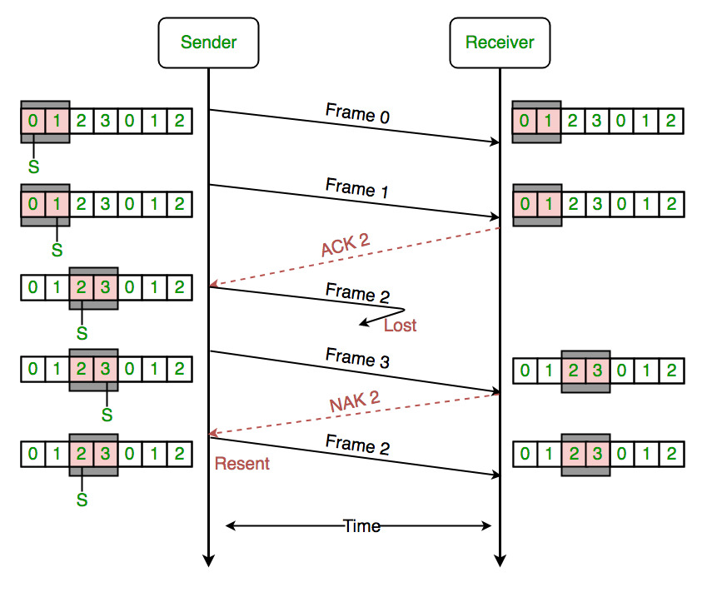
Figure –the sender only retransmits frames, for which a NAK is received
Efficiency of Selective Repeat Protocol (SRP) is same as GO-Back-N’s efficiency :

- Efficiency = N/(1+2a)
- Where a = Propagation delay / Transmission delay
- Buffers = N + N
- Sequence number = N(sender side) + N ( Receiver Side)

- Sliding Window protocols Summary With Questions
Stop and wait –
- Sender window size (Ws) = 1
- Receiver window size (Wr) = 1
- Sequence Number ≥ 1 + 1
- Uses independent acknowledgement
- Discards out of order packets
- Packet Loss ? Retransmit packet after time out
- Acknowledgement loss ? Resends packet after time out
- Efficiency = 1/(1+2a) where a = Tp/ Tt
Go Back N –
- Sender window size Ws= N
- Receiver window size Wr= 1
- Sequence number ≥ N + 1
- Can use both cumulative or independent acknowledgement depends on acknowledge timer
- Discards out of order packets
- Packet Loss ? Track back N size from the last packet within the window limit to the lost packet and retransmit them
- Acknowledgement loss ? If not received before timeout the entire window N size is resend
- Efficiency = N/(1+2a) where a = Tp / Tt

Selective Repeat –
- Sender window size Ws= N
- Receiver window size Wr= N
- Sequence Number ≥ N + N
- Uses only independent acknowledgement
- Can Accept out of order packets
- Packet Loss ? Resend only the lost packet after timeout
- Acknowledgement loss ? Resend if not receive before timeout
- Efficiency = N/(1+2a) where a = Tp / Tt

Practice Questions –
- Example-1. In Stop and wait protocol every 4th packet is lost and we need to send total 10 packets so how many transmission it took to send all the packets?
- Explanation –
1 2 3 4 5 6 7 8 9 10 (Initially)
^
1 2 3 4 4 5 6 7 8 9 10 (Packet no. 4 retransmitted)
^
1 2 3 4 4 5 6 7 7 8 9 10 (Packet no. 10 retransmitted)
^
1 2 3 4 4 5 6 7 7 8 9 10 10 (Result)
So, we retransmitted packet noumber 4, 7, 10
Total count = 13
- Example-2. In S&W protocol if Error probability is p and no. of packets to send is ‘n’. How many packets we have to send ?
- Explanation –
Total retransmissions
= n*p0+ n*p1+ n*p2 + n*p3+ n*p4+ …
= n(1 + p + p2+ p3+ p4+ …)
= n*(1 / (1-p)) using infinite GP sum formula
- Example-3.In GBN sender Window size = 10 and Tp= 49.5ms & Tt= 1ms. What is the Efficiency of the protocol and Throughput given Bandwidth = 1000 bps?
- Explanation –
Efficiency = N/(1+2a), N = 10 (given), a = Tp/Tt = 49.5
Efficiency = 10/(1 + 2 * 49.5) = 10/100 = 0.1 or 10%
Throughput = Efficiency * Bandwidth
= 0.1 * 1000 = 100
- Example-4.In GB3 if every 5th packet is lost & we need to send 10 packets so how many retransmissions are required ?
- Explanation –
1 2 3 4 5 6 7 | 8 9 10
^ $ (packet no. 5 lost)
1 2 3 4 5 6 7 5 6 7 8 9 | 10
* ^ $
1 2 3 4 5 6 7 5 6 7 8 9 7 8 9 10
* ^ $
1 2 3 4 5 6 7 5 6 7 8 9 7 8 9 10 9 10 (count starts from * till ^)
(from ^ to $ retranmission is done)
Note – From the Last packet is window size to lost pocket we resend the entire window.
Total no. of transmissions = 18
- Example-5. In SR Ws = 5 and we are sending 10 packets where every 5th packet is lost find number of retransmissions?
- Explanation –
1 2 3 4 5 6 7 8 9 10
^
1 2 3 4 5 5 6 7 8 9 10
^
1 2 3 4 5 6 7 8 9 9 10
We see here there is no role of Window size in SR only the lost packet is resent.
Total transmissions = 12
- Example-6.If there is K bits sequence no. define require sender window size and receiver window size for S&W, GBN & SR?
Explanation –
Given, K bits, For S&W Ws= 1 and Wr= 1
For GBN, Ws= 2K-1 and Wr= 1
For SR, Ws= 2K-1 and Wr = 2(K-1)

Difference between Stop and Wait, GoBackN and Selective Repeat

- Stop and Wait–
The sender sends the packet and waits for the ACK (acknowledgement) of the packet. Once the ACK reaches the sender, it transmits the next packet in row. If the ACK is not received, it re-transmits the previous packet again.
- Go Back N–
The sender sends N packets which is equal to the window size. Once the entire window is sent, the sender then waits for a cumulative ACK to send more packets. On the receiver end, it receives only in-order packets and discards out-of-order packets. As in case of packet loss, the entire window would be re-transmitted.
- Selective Repeat–
The sender sends packet of window size N and the receiver acknowledges all packet whether they were received in order or not. In this case, the receiver maintains a buffer to contain out-of-order packets and sorts them.The sender selectively re-transmits the lost packet and moves the window forward.
Differences:
Properties | Stop and Wait | Go Back N | Selective Repeat
Sender window size | 1 | N | N
Receiver Window size | 1 | 1 | N
Minimum Sequence number | 2 | N+1 | 2N
Efficiency | 1/(1+2*a) | N/(1+2*a) | N/(1+2*a)
Type of Acknowledgement | Individual | Cumulative | Individual
Supported order at Receiving end | – | In-order delivery only | Out-of-order delivery as well
Number of retransmissions in case of packet drop | 1 | N | 1
Where,
- a = Ratio of Propagation delay and Transmission delay,
- At N=1, Go Back N is effectively reduced to Stop and Wait,/li>
- As Go Back N acknowledges the packed cumulatively, it rejects out-of-order packets,
- As Selective Repeat supports receiving out-of-order packets (it sorts the window after receiving the packets), it uses Independent Acknowledgement to acknowledge the packets.

